Transfer Trading Card Creator

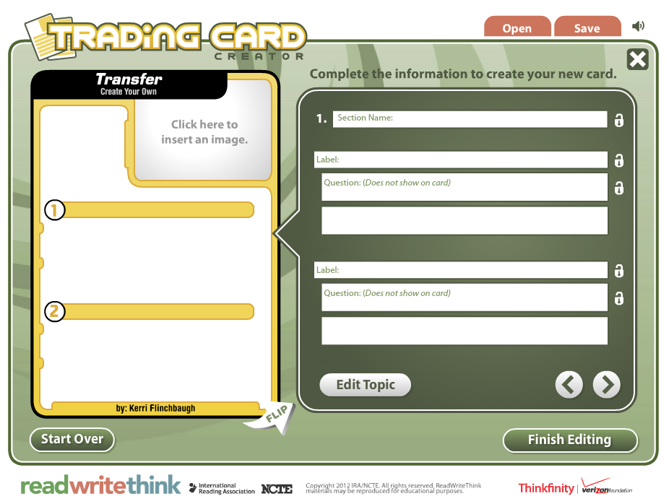
While trading cards are a fun remix activity with a genre that many students are familiar with, they can also be scaffolding tools through which we can model and ask students to practice significant ways of thinking. Read, Write, Think’s Card Creator allows students to create their own trading card about a real or fictional person, place, object, event, or abstract concept. Creators can also create a unique format to fit the context for and topic on which you are writing. (For example, today’s activity is a unique format.) The save capability gives students a way to work on a draft of their card and come back to it to rework and revise as necessary, and to save their finished product to share with friends and family. Images can be uploaded into the card to give the finished product a complete and polished look.

Context:
Purpose:
Audience:
Voice:
Format:
Topic:

Notice: There is a word limit for each section, so you may have to revise and make your answers more concise to successfully complete each section for your audience.

Also, if you would like to tweak the template to better fit your concept, feel free to do so. Also be ready to explain why you think this revision made the card more effective.

Terms: transfer (TFT), metacognition, threshold concepts, communities of practice, genre, troublesome knowledge, previous experience, expertise
Transfer Trading Card Creator Directions

- Click on the link on the Prezi, or go to readwritethink.org. In the Search By Keyword box on the left, type “card creator”. Click on the top link, Trading Card Creator.
- Click on Get Started. <Flash Player required>
- Enter your name and click Start.
- In the Topic space, type in your concept. (For example, threshold concept.) Then, click on Create Your Own.
- Click on space to insert image and select your image.
- Fill in the section name (like Background) and label (like Definition, and Related scholars) on the front of the card. Respond the questions posed below in the space provided for each answer. Note: You do not have to type in the questions provided below. When questions are provided for each topic, the text of the questions does not appear on the trading card itself.
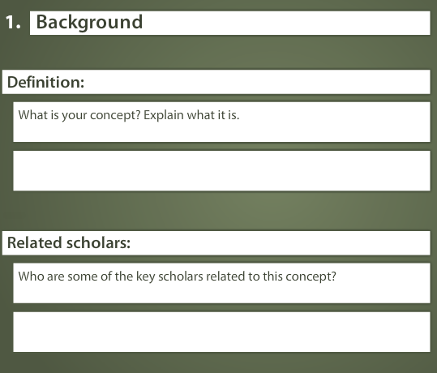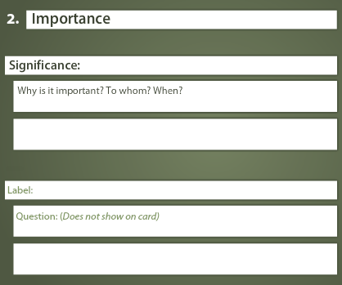
- Repeat for the back of the card.
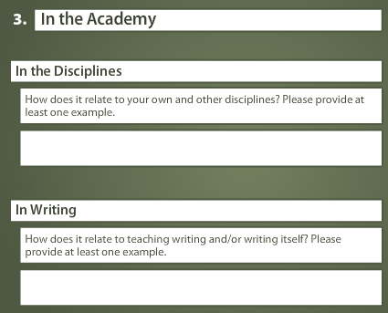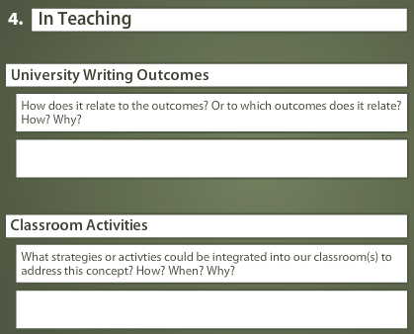

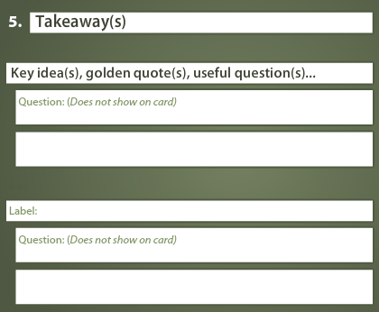
- Click Finish Editing. Save your card as a PDF by selecting Save Final. Please email your card to Kerri (flinchbaughk@ecu.edu) or post it to our blog.

