Synthesis of Ideas: Literature Review

The Dinner Party Research Conversation
1. You are hosting a dinner party for the authors listed in your annotated bibliography and a representative member of your primary audience. If you know you’re composing for a specific journal, you might want to invite the editor. You and the editor will sit across the table from each other, as this conversation is primarily between the two of you; however, you’ll need your guests to speak up on behalf of the research argument you are trying to build. Every good host knows you must seat the right people beside each other, so figure out who could converse with whom (which authors are talking about the same theme, method, concept, approach...), and arrange your authors accordingly.
2. Draw some circles around guests or arrows between those who would likely engage each other in side conversations. What would they talk about? Use some keywords to indicate these themes, methods, methodologies, studies, concepts, approaches, etc. and/or create some symbols (drinks, food items…) with a key.
3. Now you’ll imagine and compose the dialogue that would likely happen over dinner. Your job is to start the conversation with your primary audience member and let others naturally jump when they can productively contribute to the dialogue. By the end of the dialogue, you should have reasonably convinced your audience member of the purpose of your research project, and the last line of dialogue should be from that audience member, indicating his or her assent.
4. Have fun and remember that you are the host– don’t let any one guest take over YOUR conversation.

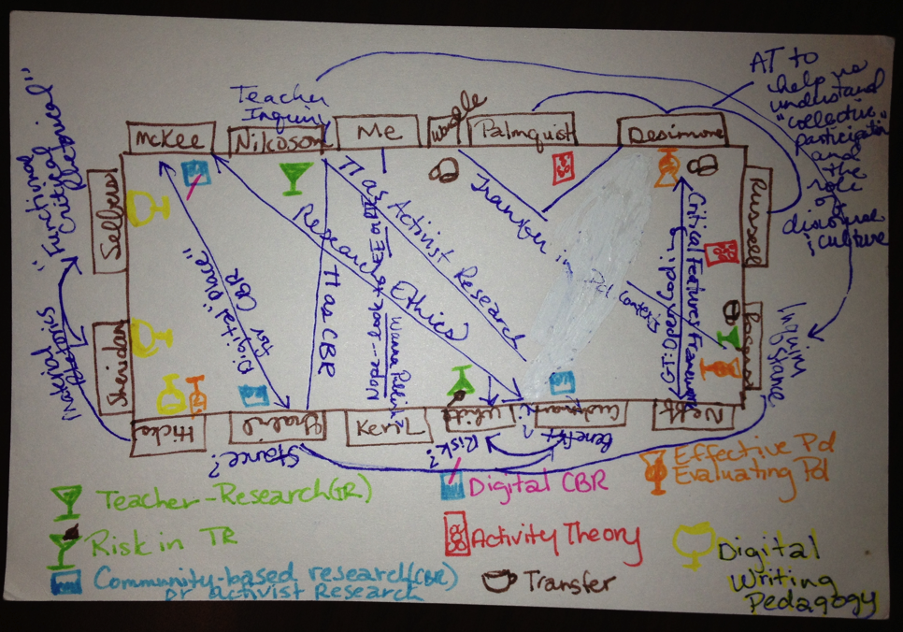

First Annual Archival Potluck Dinner

Dinner guests: Barbara L’Eplattenier, Robert Connors, Will Banks, Cheryl Glenn, Kerri Flinchbaugh
Setting: A large wooden table with a low-lit, low-hanging, art deco chandelier above. The table setting is simple but elegant. A few low, tapered candles sit among a small arrangement of wildflowers carefully arranged and placed in the center.
The fresh green salad with roasted pears and several “good”cheeses that Barbara brought in a lovely cobalt bowl sits on the sidelines, now more than less than half full. Cheryl’s pasta pesto with local, heirloom tomatoes is currently the focus of most people’s attention. And Robert’s Radison, Merlot (2000) only has a ring of burgundy circling the bottle’s bottom. Kerri brought the bread.
Barbara (smiling warmly): Banksie, I can’t wait for the raspberry tart you brought for dessert. How is Wendy doing?
Will: She’s good. Good, but busy. With the QEP and all…
Robert: Oh, yes. Your writing QEP. Are you starting in the archives with that?
Will: We will get there. One aspect of the QEP is creating an archive of student writing in e-portfolios. We will see where it goes from there. You know how it goes, Dr. Bob. (smiling, joking) This is the work part. We will get to the playing later.
Cheryl: Taking into account the remapping activities of our discipline, the possibilities are endless with these student portfolios. [pause] I am interested to see how you will complicate the reading of the students’ writings. Have you considered the lens from which your readers will be examining the student writing? Which will provide the richest, fullest picture?
[No response. Thinking.]
Kerri: I have actually been wondering lately if Bob Broad’s ideas on Dynamic Criteria Mapping could be a useful tool in the historiographical, feminist, and gender methods offered by Bizzlle, Cheryl. And also in the role DCM could possibly play in the QEP.
Will (smiling knowingly): All good assessment is organic, local, and formative.
Cheryl: I’m not quite seeing how DCM would fit in with Bizzle’s angles… I don't see my work and assessment...seems like apples and oranges, possibly.
Kerri: I was just wondering if DCM could be a tool in helping us figure out, help us identify what we value within our angles. What are our values and our lens’s values?
Cheryl: Perhaps…
Barbara (abruptly, but not harshly, turning her attention): Dr. Bob, I honestly have a little bone to pick with you. This playing in the achieves business… Don’t you think that makes the whole process of archival research a little too… mystical?
Robert (curious but playful): Mystical?
Barbara: Silly?
Robert: Silly?
Barbara: Unclear. I mean, “a mushroom hunt”?! (chuckles all around)
Robert: Well, honestly Barbara, I had a question for you also. This addition of a methods section in our archival research products… I noticed in your list of reasons of why this is such a great idea that there is no mention of the greater implications, outside of composition and rhetoric. Isn’t it the stories that are what is important in our research? This addition of methods… It’s tilting at windmills… Attempting to deconstruct epistemic certainties that may be better left intact. (smiling, chuckling) “I will friend you, if I may.” If not,… oh well! (smiles) We still have our stories. [thoughtful quietness] Besides, couldn’t adding such a section be viewed as a mere attempt to conform to the quantitative, scientific disciplines? Just an attempt to make ourselves more “reliable” or more “valid” in some way?
Will: What’s the difference? We’re not writing for them anyway, why should their interpretations be our priority? If they see it as more valuable, so what? If not… oh well. What is the value and purpose in it for us? Our students?
Cheryl: I see where Barb is coming from. I will be the first to point out - in my very postmodern way - that we do all have angles, and they do make us skeptical about the procedures that legitimized and mapped out the history of rhetoric in the first place.
Will: Okay. Who wants raspberry tart?

